**Database II Lab sheet- 3**

01)

02) BEGIN

SET NEW.FirstName = TRIM(NEW.FirstName);

SET NEW.LastName = TRIM(NEW.LastName);

SET NEW.Country = UPPER(TRIM(NEW.Country));

END

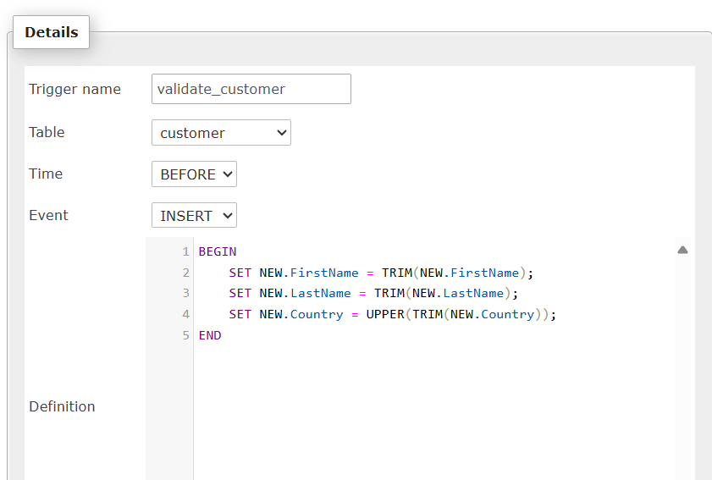



03)

CREATE TABLE AuditLog (

LogID INT AUTO_INCREMENT PRIMARY KEY,

TableName VARCHAR(50),

OperationType VARCHAR(20),

ColumnName VARCHAR(50),

OldValue TEXT,

NewValue TEXT,

OperationTime TIMESTAMP DEFAULT CURRENT_TIMESTAMP

);

BEGIN

IF OLD.FirstName <> NEW.FirstName THEN

INSERT INTO AuditLog (TableName, OperationType, ColumnName, OldValue, NewValue)

VALUES ('customer', 'UPDATE', 'FirstName', OLD.FirstName, NEW.FirstName);

END IF;

IF OLD.LastName <> NEW.LastName THEN

INSERT INTO AuditLog (TableName, OperationType, ColumnName, OldValue, NewValue)

VALUES ('customer', 'UPDATE', 'LastName', OLD.LastName, NEW.LastName);

END IF;

IF OLD.Country <> NEW.Country THEN

INSERT INTO AuditLog (TableName, OperationType, ColumnName, OldValue, NewValue)

VALUES ('customer', 'UPDATE', 'Country', OLD.Country, NEW.Country);

END IF;

IF OLD.Phone <> NEW.Phone THEN

INSERT INTO AuditLog (TableName, OperationType, ColumnName, OldValue, NewValue)

VALUES ('customer', 'UPDATE', 'Phone', OLD.Phone, NEW.Phone);

END IF;

END;

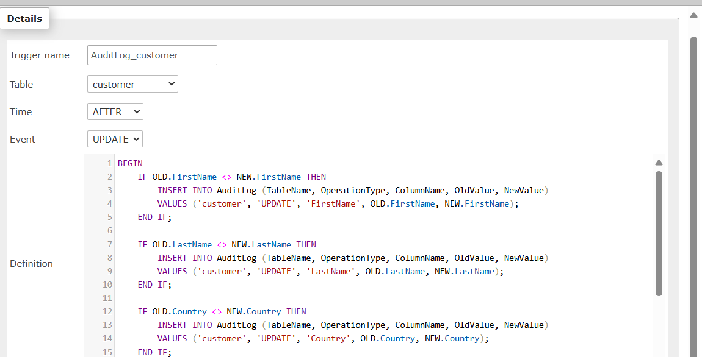

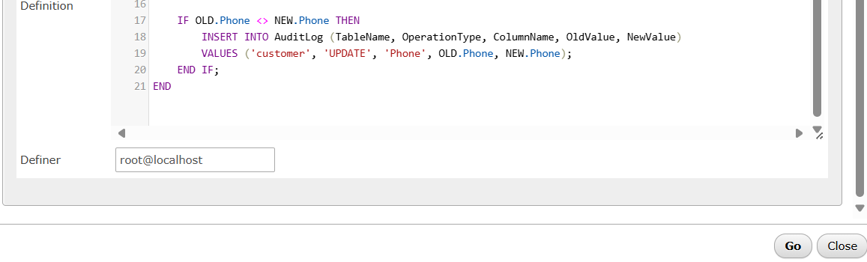

UPDATE customer

SET FirstName = 'Anna', Phone = '981-447766'

WHERE id = 92;

